Business Requirement Document

Data Hydration

Version Number: 1

|  |  |  |  |  |  |
| --- | --- | --- | --- | --- | --- |
| **Document Revision Control Table** | | | | | |
| **Version No.** | **Date Revised** | **Change Description** | **A/M/D (Add/Modify/ Deleted)** | **Prepared By** | **Approved By** |
| 1 | 09/02/2024 |  | A | Navin | Ashvin |
|  |  |  |  |  |  |
|  |  |  |  |  |  |
|  |  |  |  |  |  |

**Table of Contents**

1. Project Objectives 4
2. Background 4
3. Scope

3.1 In Scope 4

3.2 Out of Scope 4

1. Functional Requirements

4.1 Business Requirements 5

4.2 Business Process Flows 5

1. Non-functional Requirements

5.1 Performance Requirements 6

5.2 Usability Requirements 6

5.3 Security Requirements 6

5.4 Training Requirements 6

1. Reporting and quality assurance 6
2. Delivery Schedule 6
3. Constraints 6
4. Assumptions 6
5. Risks 7

**1. Project Objectives**

* Deliver a hydration application that automates the process of data extraction and insertion.
* Provide one stop solution for data extraction, validation and insertion.
* Avoid using manual queries for data insertion.
* Supports conversion of data from one form to another.
* Reduce time taken for data insertion.
* Used in fresh finacle installation.

1. **Background**

Automation of process of data extraction and insertion will reduce development efforts across the enterprise by eliminating manual queries in deployed. EV finacle team uncovered seriously high levels of errors across testing environments, production environments and increased rework .

1. **Scope**

The project has been approved by the executive management that the project manager will handle planning and implementation of the tool. A team will help the project manager in achieving the goals of the project. With the resources provided by the company the team is expected to produce the desired result.

**3.1 In Scope**

The following areas are in scope for this project:

* Development of application for data extraction and insertion.
* Application has to be a part of finacle installation.
  1. **Out of Scope**

The following areas are out of scope for this project:

* Creation of database and tables

1. **Functional Requirements**
   1. **Business Requirements**

|  |  |  |
| --- | --- | --- |
| **S. No.** | **Requirement Description** | **Priority** |
| **1** | **Automation of process of data extraction and insertion** | **High** |
| **2** | **Development of validation tool** | **Low** |
| **3** | **Reduce time taken for installation** | **High** |
| **4** | **Containerization of tool** | **Medium** |

* 1. **Business Process Flows**

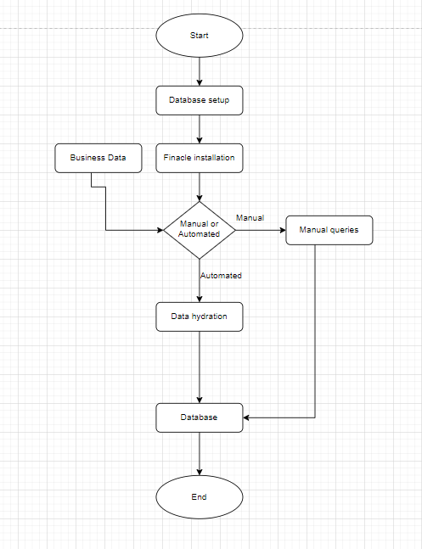

1. **Non-functional Requirements** 
   1. **Performance Requirements**

* Ensure reduced time taken for database processes.
* Ensure reduced memory usage during the database processes.
  1. **Usability Requirements**
* Preparation of a manual for tool usage.
  1. **Security Requirements**
* Ensure usage of secured packages in application.

1. **Reporting and quality assurance**

* **Reviews and audits**: Technical reviews should be performed by project manager to uncover problems and ensuring that quality guidelines are being followed by the team.
* **Testing**: The test plan has to be created and executed to ensure that the application is free of errors.
* **Security**: Ensure that the application uses appropriate processes and technologies.

1. **Delivery Schedule**

|  |  |  |
| --- | --- | --- |
| **Delivery Name** | **Functionalities Delivered** | **Tentative Dates** |
| Initial version of tool | Data extraction and insertion | 01/03/2024 |
|  |  |  |
|  |  |  |

1. **Constraints**

* Unavailability of a separate testing team.
* Initial version of the tool must be ready within a month.
* Only small percentage of funding for project available in current financial year.
* Team skilled with technologies and tools used.

1. **Assumptions**

* No Dedicated testing team is required.
* Enough human resources are available for the successful development of the project.

1. **Risks**

|  |  |  |  |
| --- | --- | --- | --- |
| **Type of Risk** | **Risk Description** | **Affects** | **Severity** |
| **Organizational Risk** | **Stick to the budget and track the project’s expenses to be on top of potential issues in budget** | **Resource availability for successful completion of project** | **High** |
| **External Risk** | **User friendly tool** | **The client using the tool** | **High** |
| **Project Management Risk** | **Dependencies on other teams** | **Efficient development and deployment of the tool** | **Medium** |
| **Technical Risk** | **Availability of skilled people to handle different technolgies** | **The development of the tool** | **High** |